PERSONAL INFORMATION | Bsc Senka Vuković
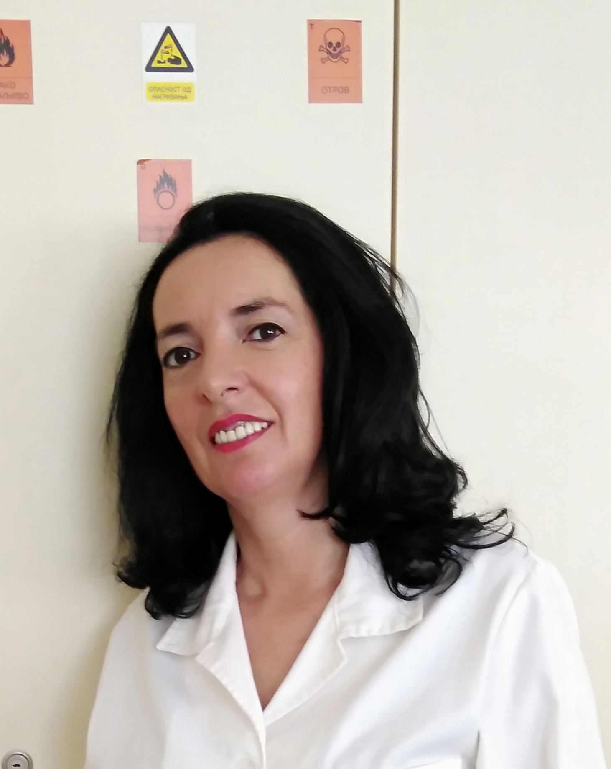 |   Trg Dositeja Obradović 6, 21000 Novi Sad

021/485-2401

senkavukovic@uns.ac.rs

WORK EXPERIENCE
1999 – 2007  2007 – 2016 | Laboratory technician
1999 – 2007  2007 – 2016 | Department of Environmental and Occupational Safety Engineering, Faculty of Technical Sciences, University of Novi Sad
1999 – 2007  2007 – 2016 | Laboratory Associate
1999 – 2007  2007 – 2016 | Department of Environmental and Occupational Safety Engineering, Faculty of Technical Sciences, University of Novi Sad
2016 – | Viši tehnički saradnik 2016 -
 | Department of Environmental and Occupational Safety Engineering, Faculty of Technical Sciences, University of Novi Sad
- Practical work with students in all courses with subjects that have a program for laboratory work in chemistry
- Procurement, storage and storage of chemicals for laboratory exercises
- Responsible person for the training and protection of students and staff when working in the laboratory and with chemicals
- Laboratory in the Accredited Laboratory for monitoring landfills, wastewater and air from 2008

EDUCATION AND TRAINING
1985.  2012. | High school – an assistant researcher in chemistry
1985.  2012. | High school Nikšić
1985.  2012. | Department of Environmental and Occupational Safety Engineering, Faculty of Technical Sciences, University of Novi Sad
 | Bsc Environmental engineering and occupational safety
PERSONAL SKILLS
Mother tongue(s) | Serbian language
Other language(s) | UNDERSTANDING |  | SPEAKING |  | WRITING
Other language(s) | Listening | Reading | Spoken interaction | Spoken production
English language | A1 | A1 | A1 | A1 | A1
Russian language | A1 | A1 | A1 | A1 | A1

Communication skills | - good communication skills acquired at the place of insurance sales manager and longtime work with students and faculty at faculty

Organisational / managerial skills | - leadership - management and organization of work for up to 10 people

Digital skills | SELF-ASSESSMENT
Digital skills | Information processing | Information processing | Information processing | Information processing | Information processing
 | Independent user | Proficient user | Proficient user | Proficient user | Proficient user

Other skills | - highly developed trading skills

ADDITIONAL INFORMATION

Licenses  Seminars, courses and trainings | Insurance sales manager  Training for chemicals storage and management in 2010  Training for taking, transporting and storing samples of water, air and soil in 2008  A1 level of English language in 2000  Computer school for primary and secondary levels of use in 2002

